17. What is the driving force for oxygen to move from tissue capillary blood into tissue?

The driving force is the gradient in partial pressure: at the tissue capillaries there is a partial pressure gradient for oxygen favoring diffusion from tissue capillaries to tissue interstitium.

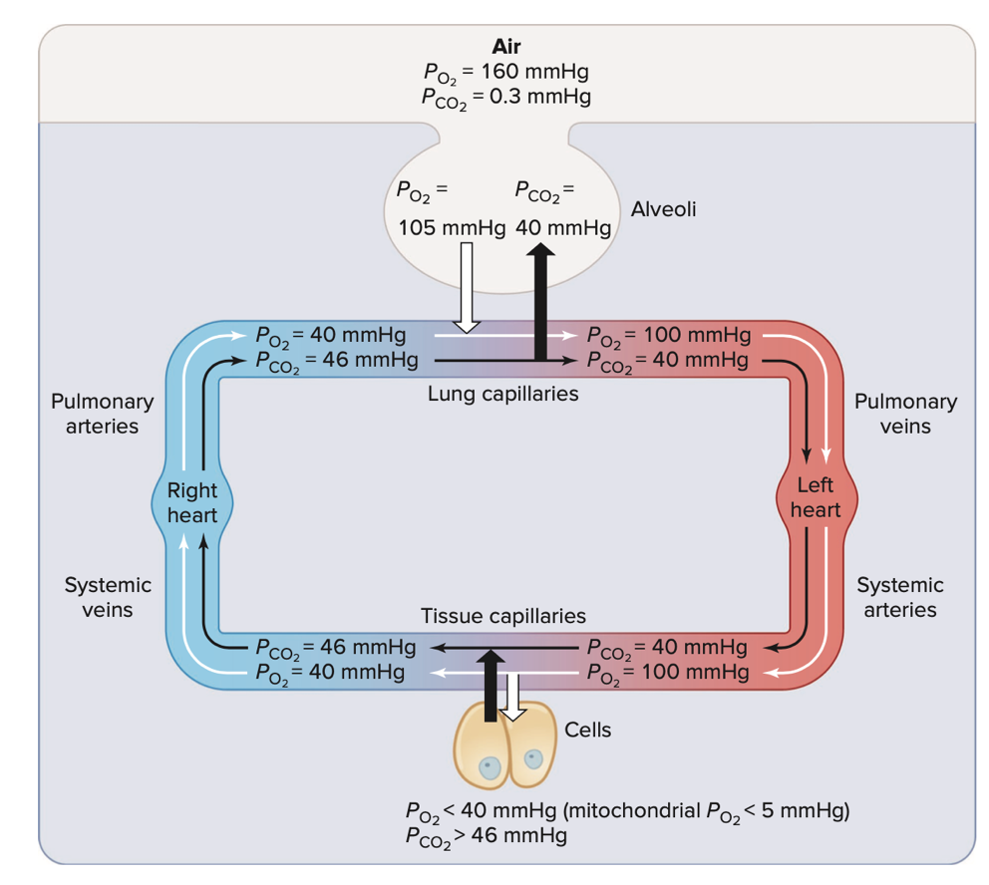

VSL[14] - figure 13.21: when blood comes to the tissue capillaries partial pressure PO2 is about 100 mmHg and the partial pressure of oxygen in the tissue is about 40 mmHg so there is a pressure gradient for oxygen to diffuse from the tissue capillaries into the interstitial fluid to the cells.

18. Explain/describe/discuss the purpose of the cilia that are found in (some of) the conducting airways.

Particulates in air inhaled, which end up in the conducting airways, can be trapped in mucus. The epithelial surfaces of the airways, to the end of the bronchioles, contain cilia, these trapped particulates are moved towards the mouth (to be expectorated or swallowed) by cilia that form a “mucus escalator” (West[10] page 9 and chapter 10).

19. With reference to the respiratory system, define the term *physiological dead space*.

The total volume of gas in each breath that does not participate in gas exchange is called the physiological dead space. It is qualified as “dead” because it is wasted ventilation and corresponds to air that is inspired but does not participate in gas exchange. This volume of air includes the anatomic dead space and the dead space secondary to perfused but unventilated alveoli:

Physiological = anatomic + alveolar dead space (Module 12, Video 1, Slide 8)

20. In the context of respiratory physiology explain/discuss/describe the difference(s) between an anatomic shunt and a physiologic shunt.

* *Anatomic shunt* or right-to-left shunt, it is an anatomical abnormality and it happens usually in the heart, and causes mixed venous blood to bypass ventilated alveoli in passing from the right side of the heart to the left side. Because of it, if an affected person is given 100% O2 to breathe, the response is blunted severely. The blood that bypasses the gas-exchanging units is never exposed to the enriched O2, and thus it continues to be deoxygenated.

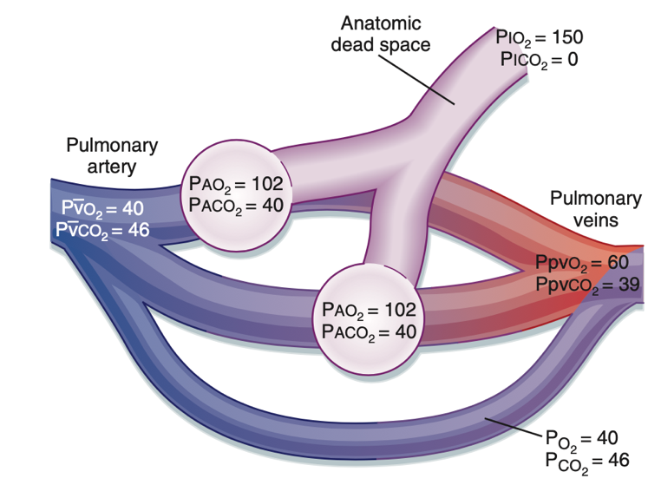

Anatomic shunt - Fig.23.9 B&L[7]

* *Physiological shunt*, an intrapulmonary defect in which mixed venous blood perfuses unventilated alveoli.

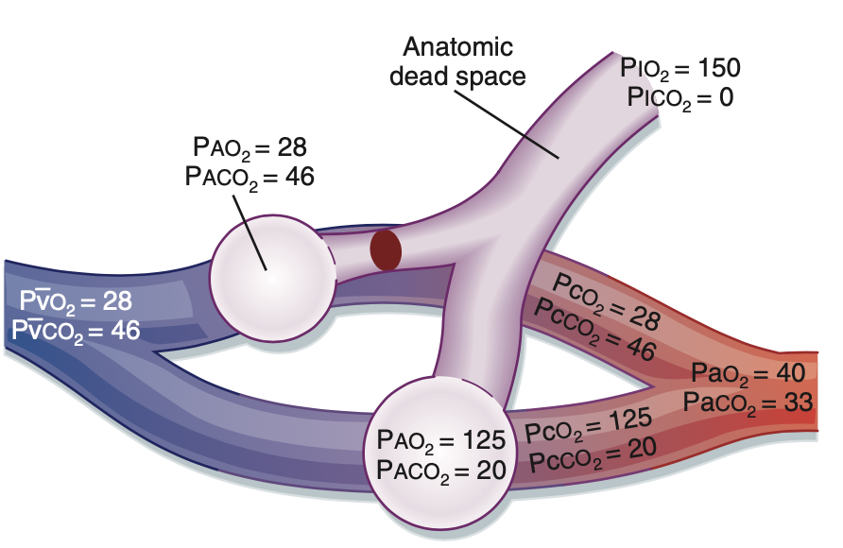

Physiological shunt - Fig.23.10 B&L[7]

21. What would be the short term (within 15 minutes or less) effect(s) on the initially at-rest breathing of a “normal” adult if their nose was clamped closed and they were required to mouth-only breathe through a cylindrical tube1 5 centimeters in diameter and 25 centimeters long? Explain briefly. You might find some calculations to be helpful; if so, show them.

Volume of a rigid tube:

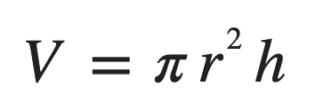

Then for r=2.5 cm (diameter divided by two), h=25 cm (length of the tube), the volume is V = 3.14 x 2.5^2 x 25 about 491 cm3 or 491mL. The air filling the tube represents the space not delivered to the alveoli ventilation for gas exchange and the volume of the tube adds up to this person anatomic dead space. In a “normal” adult the anatomic dead space is about 150ml, the anatomic dead space has increased, by about, 3 times! This large increase will reduce considerably the alveolar ventilation and tidal volume will need also to be increased in the same proportion. Eventually also, since airway resistance is proportional to the fourth power of the radius of the tube which has rather small radius compared to a large open mouth, the airway resistance will also increase.

22. Imagine a blood substitute2 in which the binding of O2 to its carrier protein is not altered by pH. How would the use of such a blood substitute affect breathing? Describe/discuss/explain briefly.

pH of the blood determines the loading/unloading of oxygen from the blood:

at the tissue capillaries, CO2 concentration is higher, and the pH decreases which results in a lower affinity of hemoglobin for oxygen enhancing the release of oxygen off the hemoglobin and providing oxygen to the cells. In the lungs, CO2 concentration is lower, pH increases, which enables the binding of oxygen to hemoglobin.

If the blood substitute is not altered by pH then the blood substitute will not load or unload oxygen, the cells will die by not receiving any oxygen.